- Make sure you have support for c++ and mfc in visual studio
- Install Python 3.7.4 32bit version.
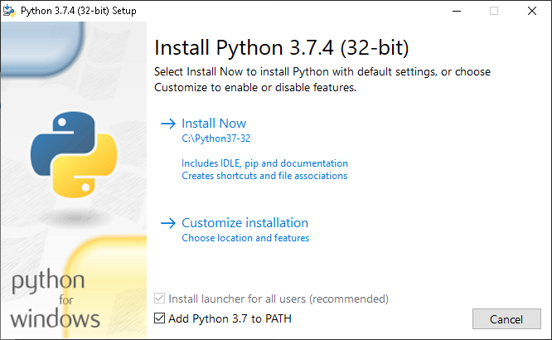
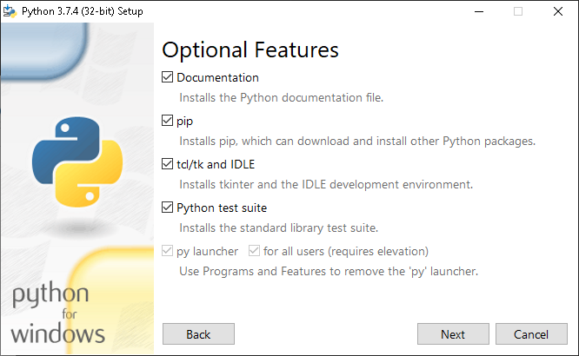

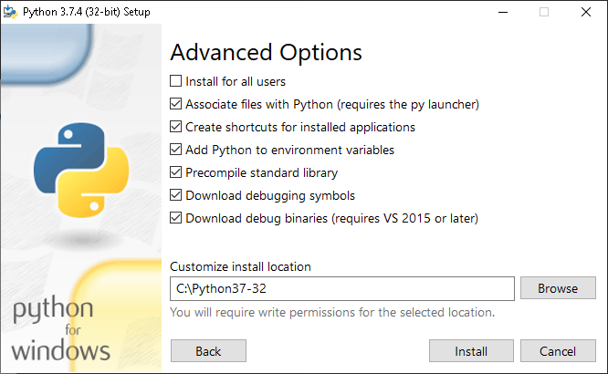

- Open the user.sln project in Visual Studio.
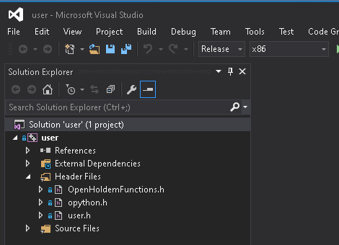
- Set the project to release x86.

- Build the solution.
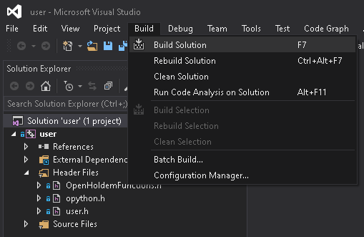
You should see 1 succeeded.
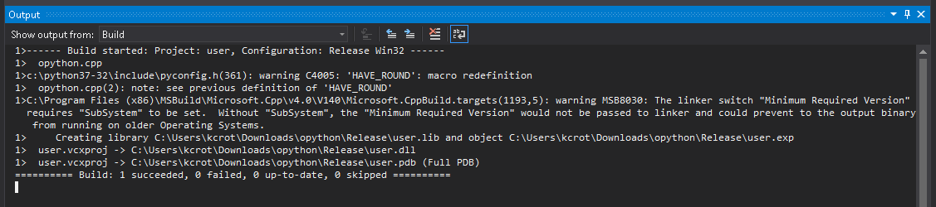

## To Run

1. Copy user.dll, PyBot.ohf and PyBot.py to OpenHoldem directory
2. Load PyBot.ohf in OpenHoldem
3. Run :)

